# **Unearthing the Environmental Impact of Human Activity:A Global CO2 Emission Analysis:**

# **1.INTRODUCTION:**

Carbon-dioxide (CO2) is released into Earths atmosphere mostly by the burning of carbon containing fuels and the decay of wood and other plant matter .Under all conditions found naturally on Earth,CO2 is an invisible ,odourless gas.IT is removed from the atmosphere mostly by plants,which is extract carbon from (CO2) to built their tissue ,and by the oceans ,in which CO2 dissolves.Carbon dioxide (CO2) makes up the largest share of man made greenhouse gases. The addition of man-made greenhouse gases to the atmosphere disturbs the earth’s radiative balance (i.e. the balance between the solar energy that the earth absorbs and radiates back into space). This is leading to an increase in the earth’s surface temperature and to related effects on climate, sea level and world agriculture.Carbon dioxide emissions or CO2 emissions are emissions stemming from the burning of fossil fuels and the manufacture of cement; they include carbon dioxide produced during consumption of solid, liquid, and gas fuels as well as gas flaring.

**1.1 OVERVIEW:**

The data set contains the carbon-dioxide emission in world wide across the countries.It is the data from 1975 to 2020.This data set contains a record of Co2 Emission by each Country and Region of Earth, here we are going to analyse and visualize Country wise, Region wise and Overall Co2 Emission on Earth.

**1.2 PURPOSE:**

Our carbon dioxide (CO2) emissions data set is one of our most-used datasets on Our World in Data. It is the key metric we need to understand our progress on slowing global climate change. the Global Carbon Project is to develop a complete picture of the global carbon cycle, including both its biophysical and human dimensions together with the interactions and feedback between them.Carbon management is an organized approach to gain the strategic advantages of CO2 emissions reductions. Carbon management helps organizations stay focused on achieving their targets to reduce CO2 emissions and their use of fossil fuels.

1. **PROBLEM DEFINITIOM AND DESIGN THINKING:**

**2.1 EMPATHY MAP:**

An empathy map is a template that organizes a user’s behaviors and feelings to create a sense of empathy between the user and your team. The empathy map represents a principal user and helps teams better understand their motivations, concerns, and user experience.

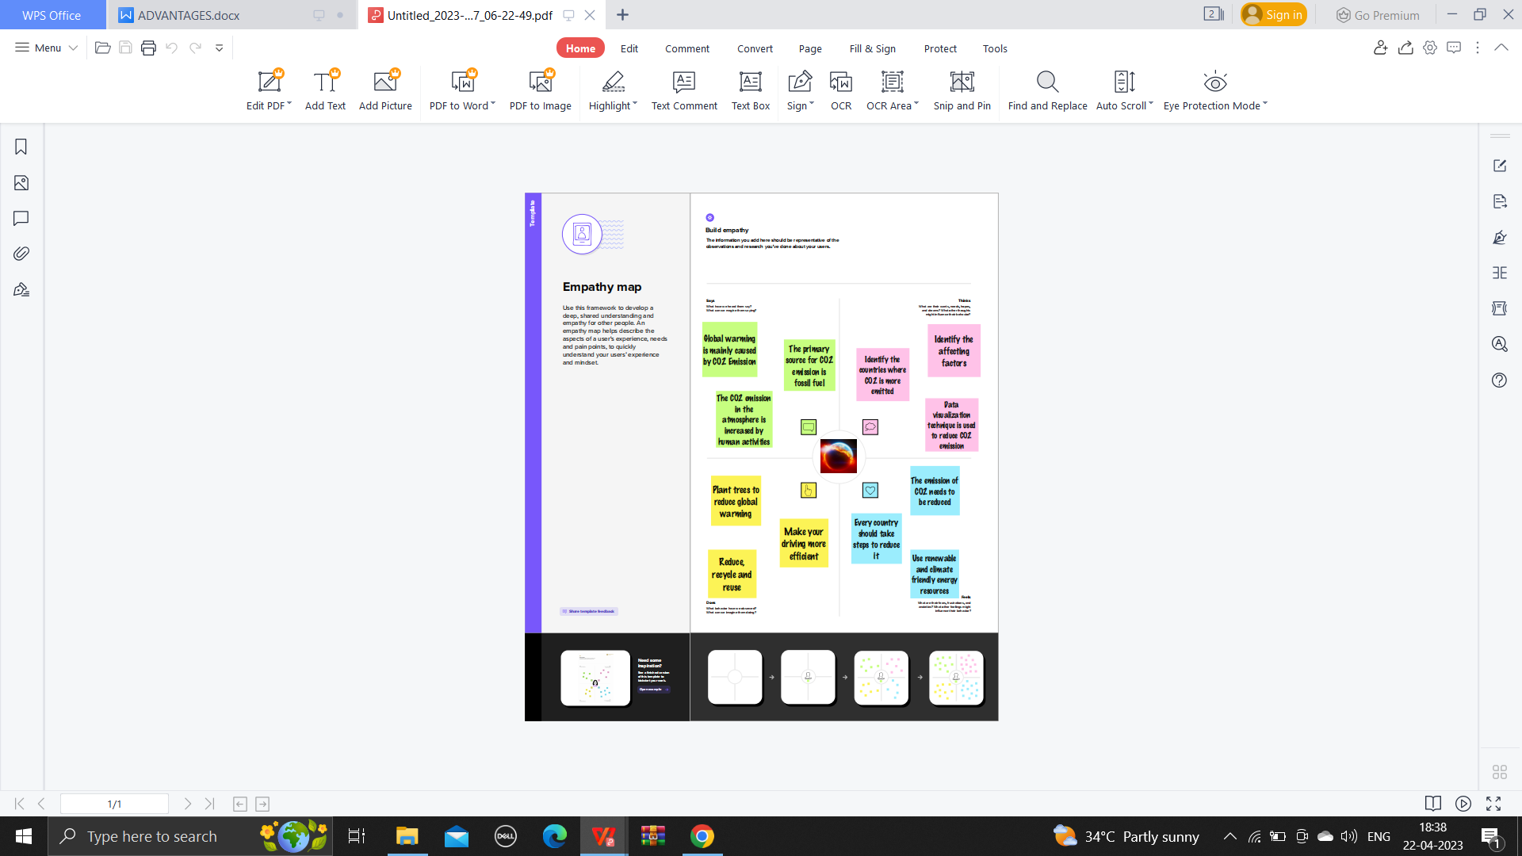

**2.2 IDEATION AND BRAINSTORM MAP:**

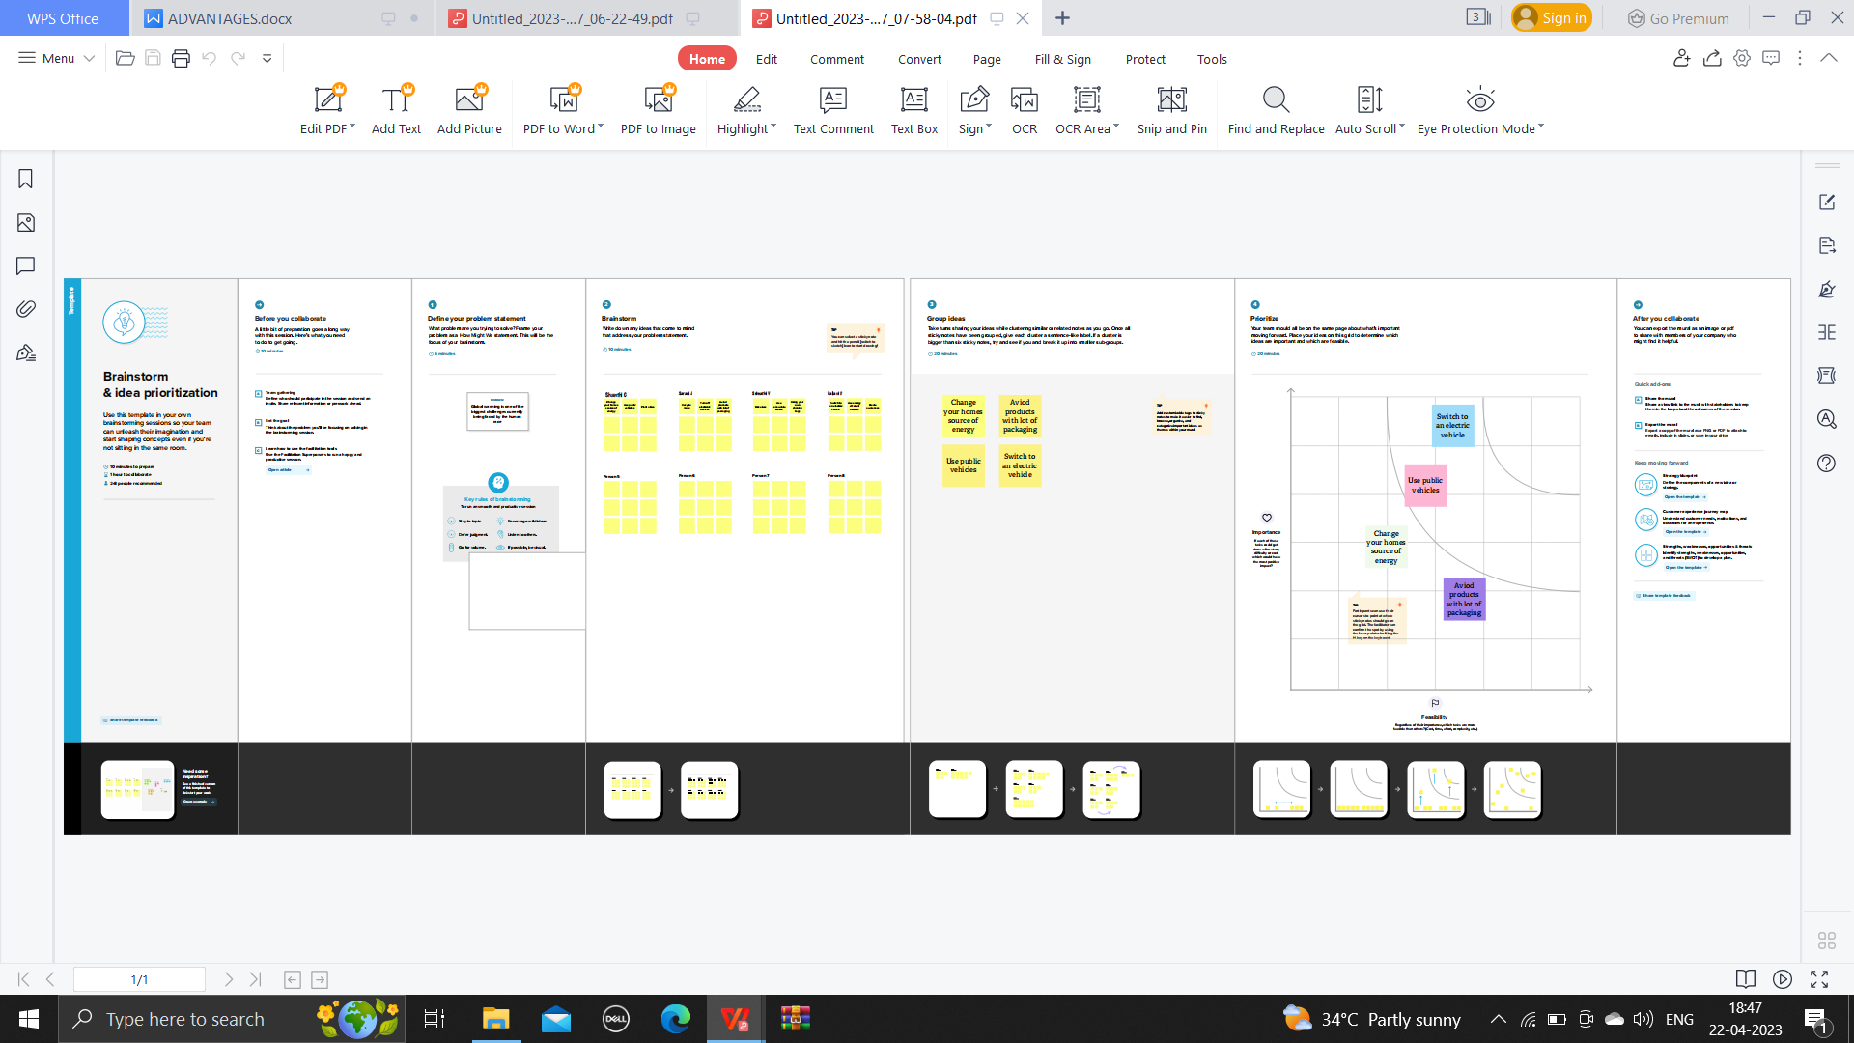



1. **RESULT:**

The output gained on the topic of Unearthing the Environmental Impact of Human Activity: A Global CO2 Emission Analysis are given below .

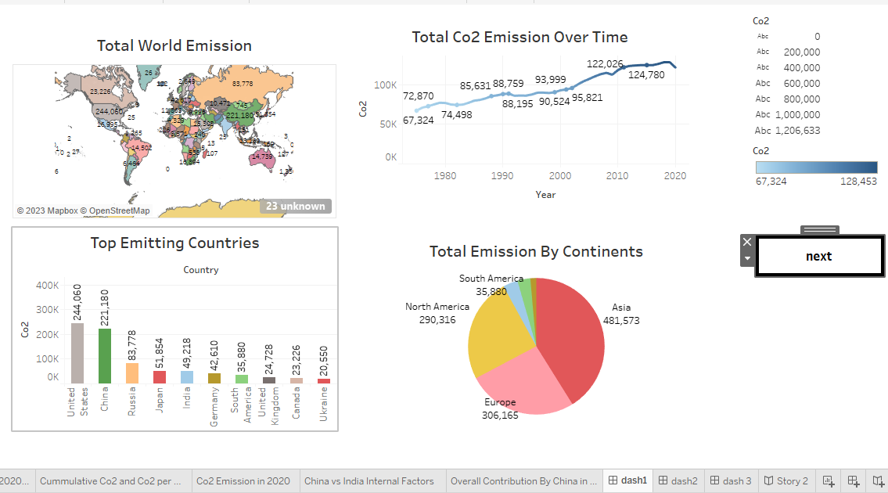

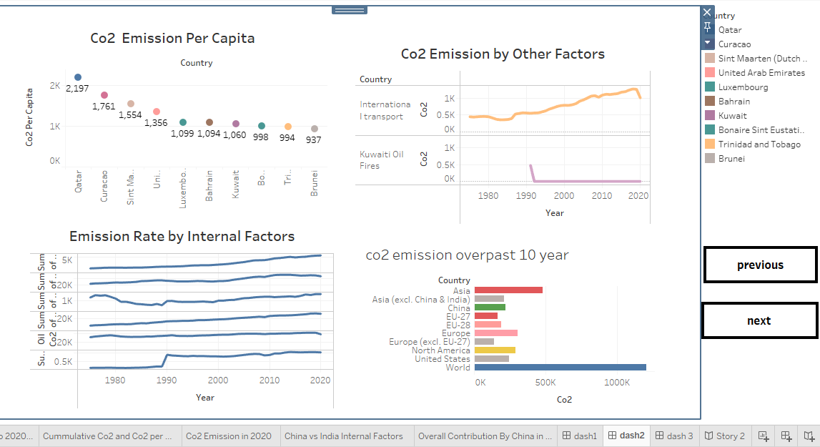

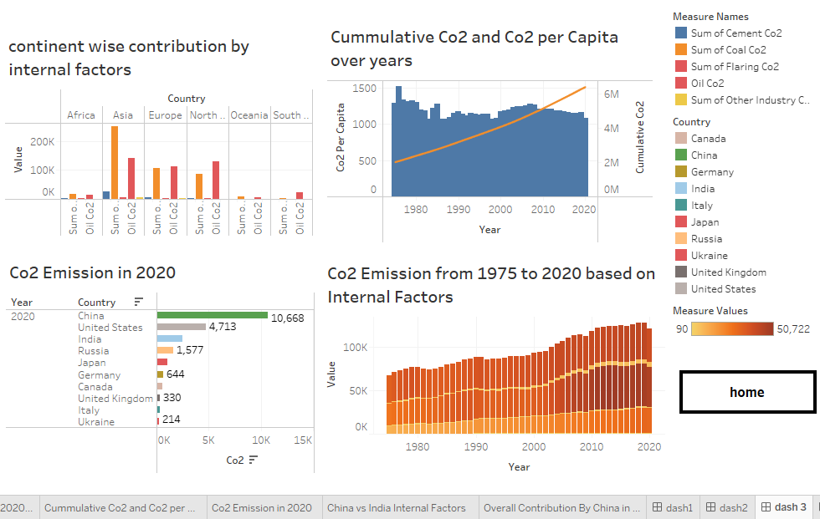

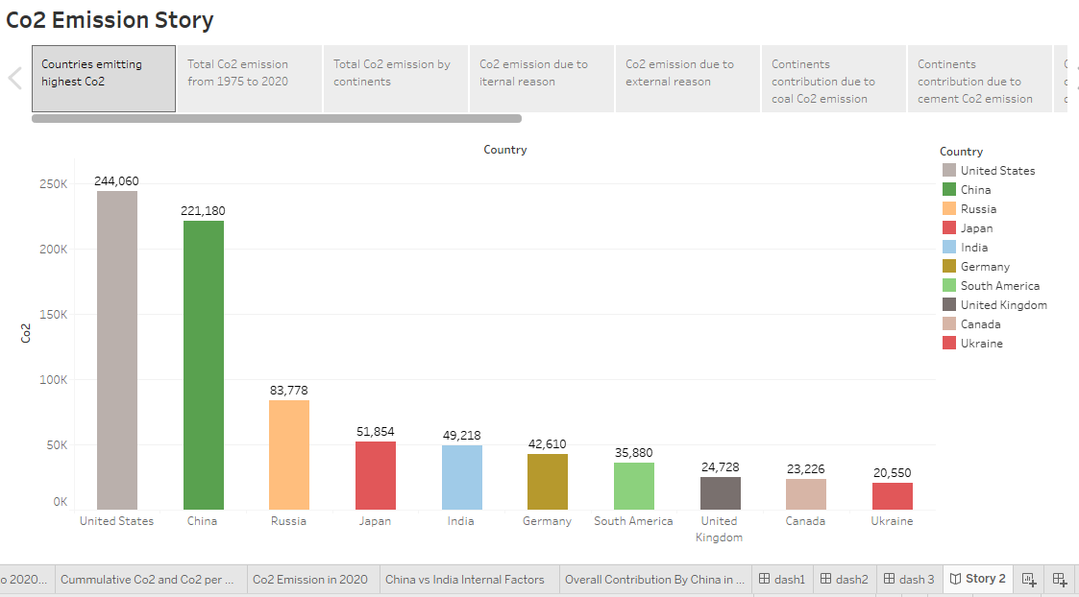

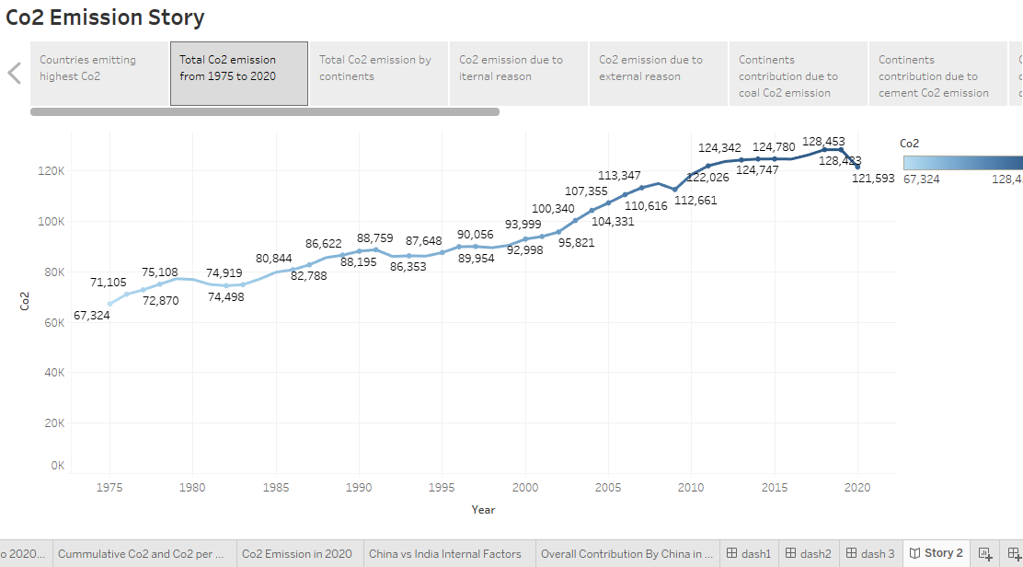

**R4**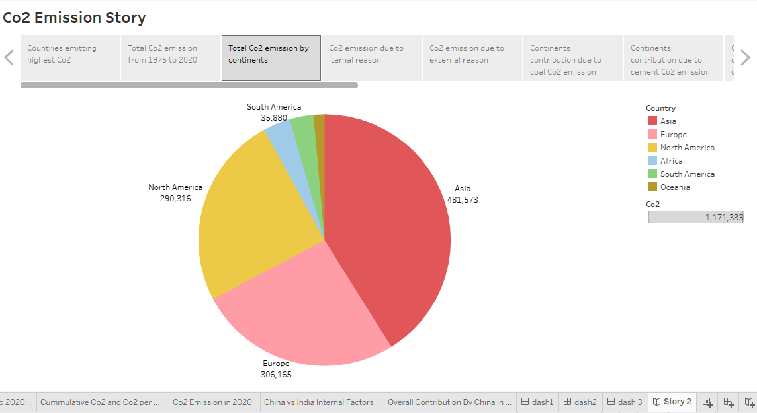

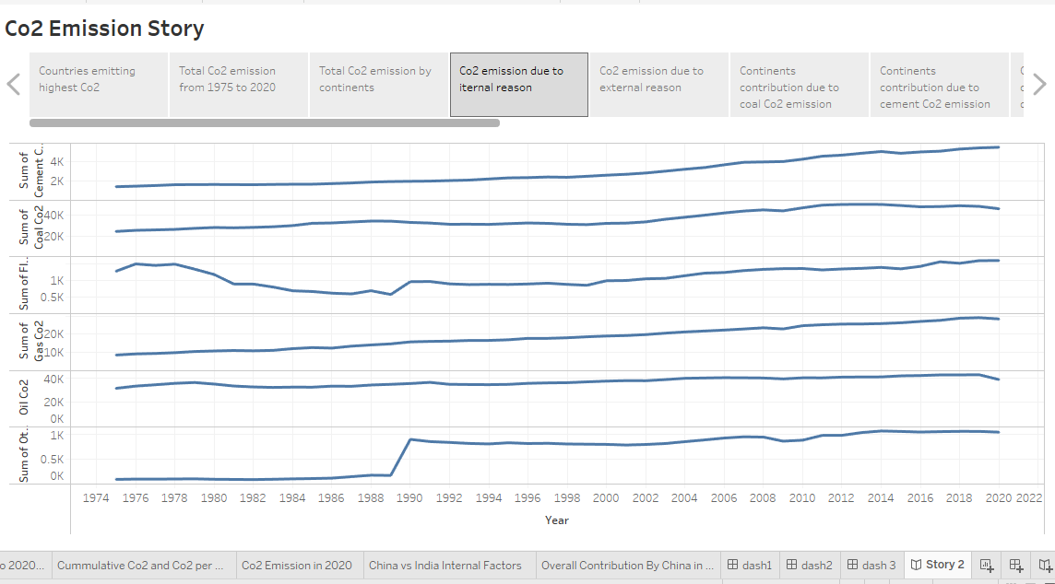

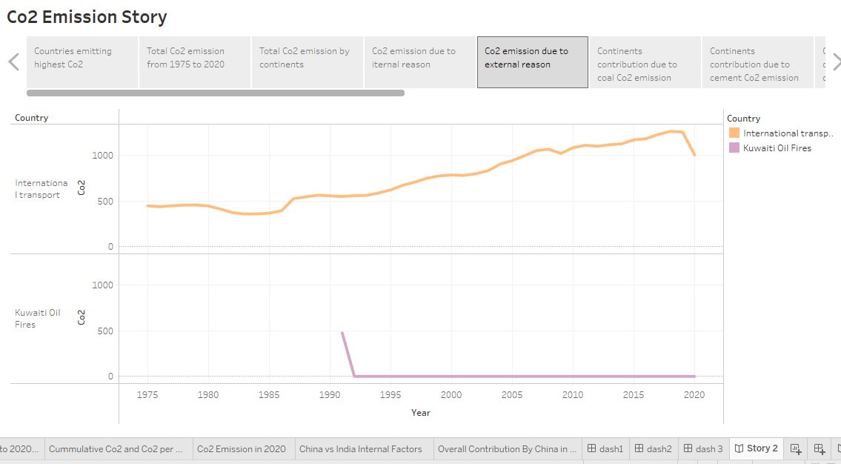

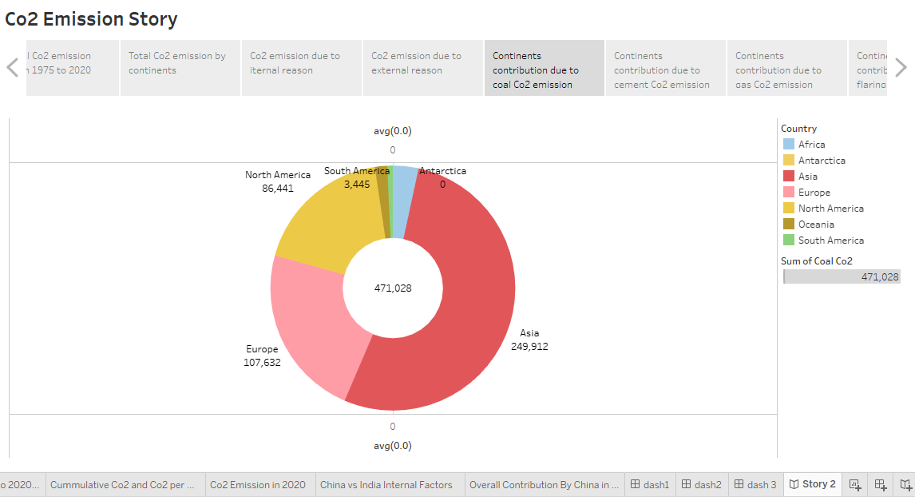

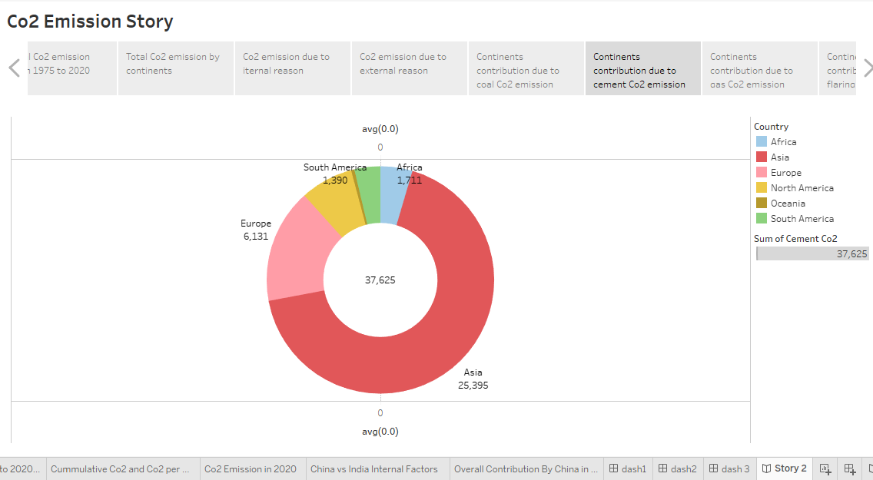

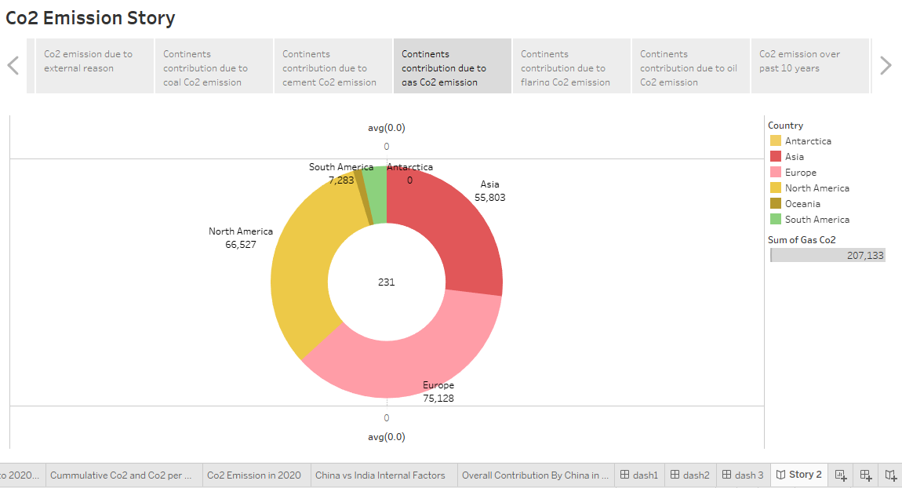

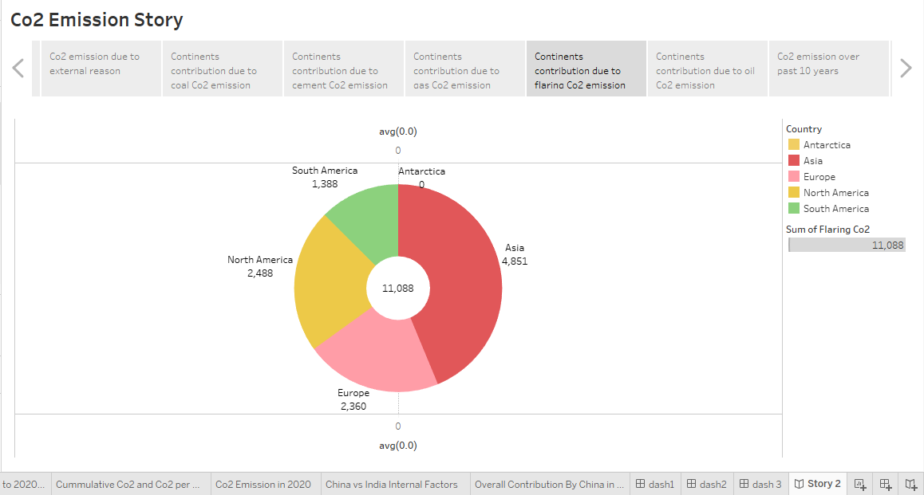

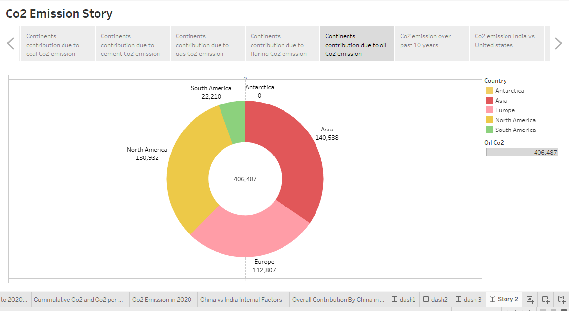

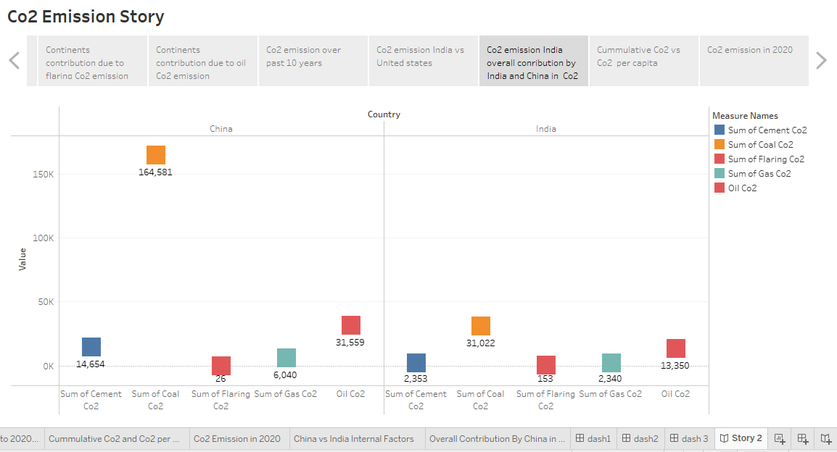

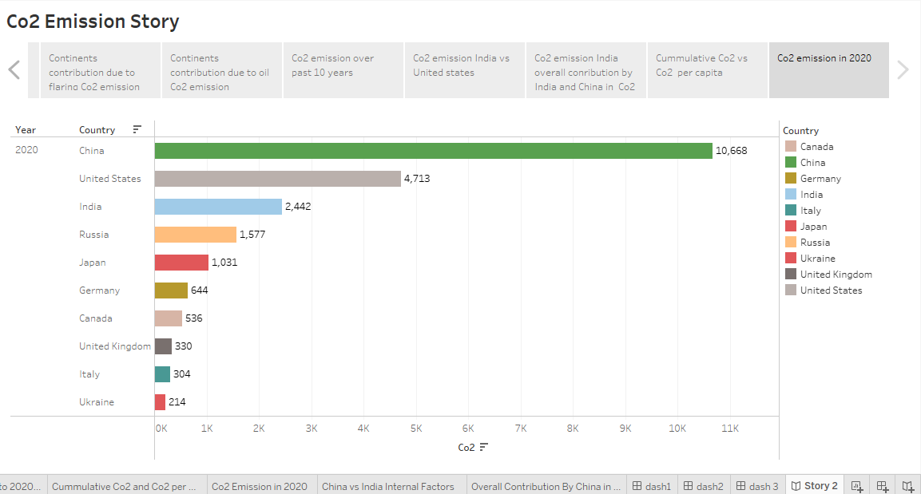

ADVANTAGES:

Benefits like improved water quality and air quality ,increases in biodiversity and habitat protection ,and reduction in greenhouse gases ,are all inherent in a strategy that protects and preserves land.Because Because air pollution and greenhouse gases are often released from the same sources, cutting greenhouse gas emissions in an effort to slow climate change also reduces air pollutants, such as fine particulate matter (PM2.5). Reducing these co-emitted air pollutants improves air quality and benefits human health.Carbon dioxide is Earth's most important greenhouse gas: a gas that absorbs and radiates heat. Unlike oxygen or nitrogen (which make up most of our atmosphere), greenhouse gases absorb heat radiating from the Earth's surface and re-release it in all directions—including back toward Earth's surface.

**DISADVANTAGES:**

High carbon dioxide levels can cause poor air quality and can even extinguish pilot lights on gas-powered appliances.High carbon dioxide levels can cause poor air quality and can even extinguish pilot lights on gas-powered appliances.Humans impact the physical environment in many ways: overpopulation, pollution, burning fossil fuels, and deforestation. Changes like these have triggered climate change, soil erosion, poor air quality, and undrinkable water.Common effects include decreased water quality, increased pollution and greenhouse gas emissions, depletion of natural resources and contribution to global climate change.

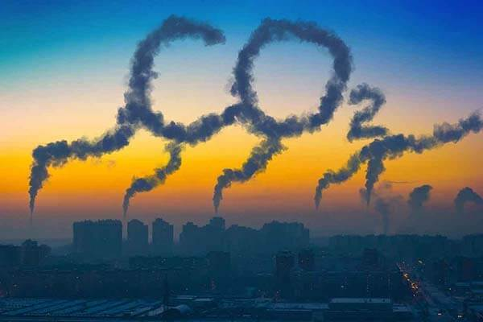

**APPILICATION:**

Carbon dioxide is used as a refrigerant, in fire extinguishers, for inflating life rafts and life jackets, blasting coal, foaming rubber and plastics, promoting the growth of plants in greenhouses, immobilizing animals before slaughter, and in carbonated beverages.CO2 is also widely used in food and beverage production, the fabrication of metal, cooling, fire suppression and in greenhouses to stimulate plant growth.

**CONCLUSION:**

Environmental impacts are changes in the natural or built environment, resulting directly from an activity, that can have adverse effects on the air, land, water, fish, and wildlife or the inhabitants of the ecosystem.Environmental impacts are changes in the natural or built environment, resulting directly from an activity, that can have adverse effects on the air, land, water, fish, and wildlife or the inhabitants of the ecosystem.

**7.FUTURE SCOPE:**

In the Annual Energy Outlook 2022 (AEO2022) Reference case, which assumes no changes to current laws or regulations, the U.S. Energy Information Administration (EIA) projects that U.S. energy-related carbon dioxide (CO2) emissions will fall to 4.5 billion metric tons in 2037, or 6% below the energy-related CO2 .The carbon (and oxygen) in CO2 can be used as an alternative to fossil fuels in the production of chemicals, including plastics, fibres and synthetic rubber. As with CO2-derived fuels, converting CO2 to methanol and methane is the most technologically mature pathway.